**Intern Task Document**

Task-1

**Project Title: Create a Personal Portfolio Page**

**Skill Focus: HTML, CSS, Bootstrap**

**🧩 Task Objective**

Design and build a **Personal Portfolio Website** using semantic HTML, custom CSS styling, and Bootstrap components. This page should effectively showcase personal information, project work, and provide a way for users to get in touch.

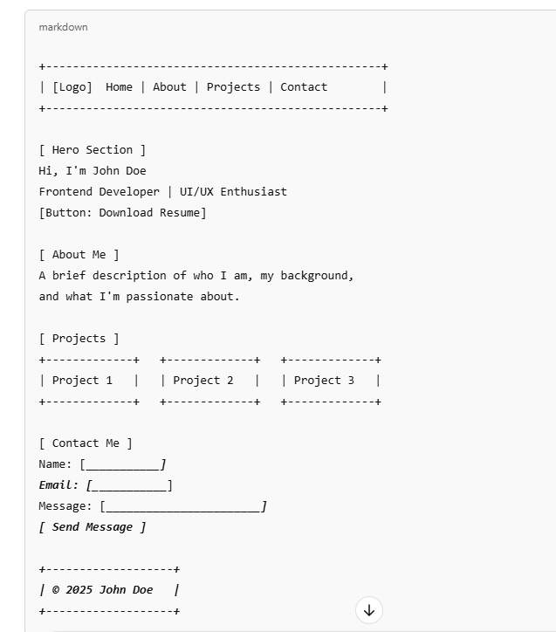

**Tools & Technologies**

* **HTML**: Semantic tags (<header>, <section>, <article>, <footer>, etc.)
* **CSS**: Custom styling for colors, fonts, spacing, responsiveness
* **Bootstrap 5**: Navbar, grid system, cards, buttons, form components

**Step-by-Step Roadmap.**

**Phase 1: Planning**

* Define your personal brand (name, title, short bio)
* Decide on 3–4 projects to showcase (can be placeholders)
* Choose color palette and fonts (Google Fonts is acceptable)

**Phase 2: HTML Structure**

* Set up base layout using semantic HTML5 tags
* Create sections:
  + **Header/Navbar** (Logo + links)
  + **Hero Section** (Intro + call-to-action)
  + **About Me** (Text content)
  + **Projects** (Three sample cards or boxes)
  + **Contact Form** (Basic inputs + button)
  + **Footer** (Copyright)

**Phase 3: Bootstrap Integration**

* Use Bootstrap 5’s **Navbar** component
* Apply **Grid system** for project layout
* Use **Card** components for projects
* Style form using Bootstrap’s **Form controls**
* Add **responsive behavior** to all sections

**Phase 4: Custom CSS Styling**

* Override Bootstrap styles for personalized design
* Add hover effects, transitions for buttons and cards
* Use media queries if needed for fine-tuned responsiveness

**Phase 5: Final Touches**

* Add favicon and title in <head>
* Ensure all sections are well-aligned and responsive
* Include a **Download Resume** button (use a dummy link or Google Drive)
* Test on different screen sizes

**🧪 Checklist Before Submission**

* Navbar with scrollable links
* Hero section with heading and call-to-action
* “About Me” section written in own words
* Project cards aligned in a responsive layout
* Fully styled contact form with submit button
* Footer with working social/profile links
* Uses both custom CSS and Bootstrap components
* Mobile and tablet responsive
* All links and buttons functional

**Task-2**

**Project Title: Product Landing Page with Login & Signup**

**Skill Focus: HTML, CSS, Bootstrap**

**🧩 Task Objective**

Design and build a modern, responsive **Product Landing Page** featuring at least three products, a navigation bar, and dedicated login/signup forms. The layout must be clean, interactive, and mobile-friendly using a combination of **HTML**, **CSS**, and **Bootstrap**.

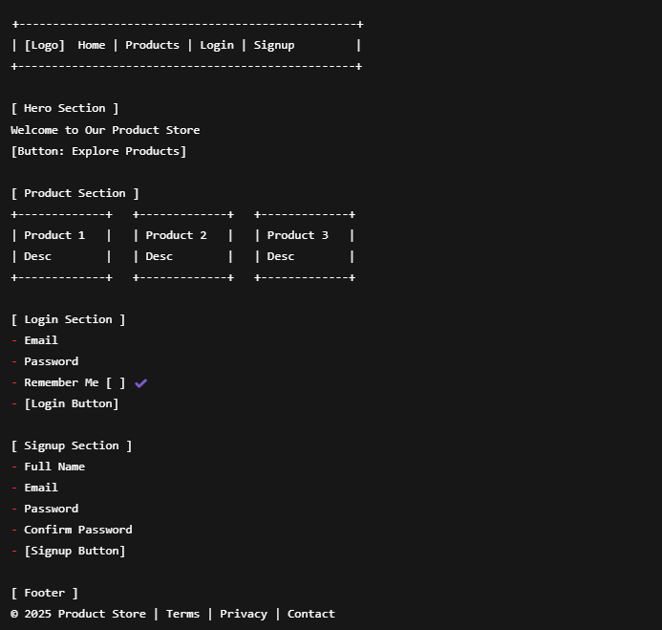

**Tools & Technologies**

* **HTML**: Structure the page using semantic tags and clean layout practices.
* **CSS**: Use transitions, hover effects, responsive layout with media queries.
* **Bootstrap 5**: Use pre-built Navbar, Card, Grid, Form, and Button components.

**Step-by-Step Roadmap**

**Phase 1: Layout Planning**

* Choose product types or use placeholders (e.g., books, gadgets, courses)
* Plan navigation flow: Home → Products → Login → Signup
* Decide on section content (titles, descriptions, labels)

**Phase 2: HTML Page Structure**

* Create base layout with:
  + **Navbar** (with navigation links)
  + **Hero Section** (welcome message and CTA)
  + **Product Cards Section** (minimum 3)
  + **Login Section** (simple form)
  + **Signup Section** (registration form)
  + **Footer** (links and legal info)

**Phase 3: Bootstrap Integration**

* Use **Navbar** component with responsive toggler
* Build **Card components** for each product using Bootstrap grid
* Use **Forms** with Bootstrap form groups for Login and Signup
* Layout form sections using **container, row, and col**

**Phase 4: CSS Styling & Interactivity**

* Apply **hover effects** on product cards and buttons
* Use **media queries** to adjust layout for mobile/tablet
* Add subtle **animations or transitions** (e.g., fade-in, scale on hover)
* Override Bootstrap styles to personalize the page (optional)

**Phase 5: Testing & Final Review**

* Ensure navigation works (jump to section or modal)
* Forms should be aligned and styled properly
* Page should work well on desktops, tablets, and phones
* All UI elements should be visually consistent and clean

**✅ Checklist Before Submission**

* Navbar with responsive toggler
* Hero section with a short welcome message and CTA
* At least 3 product cards with descriptions
* Login form with email, password, checkbox
* Signup form with full name, email, password
* Forms styled with Bootstrap components
* Custom hover effects and transitions applied
* Responsive layout on all screen sizes
* Footer with appropriate links and branding